Practical 3 - Functions and GitHub

This week (and from now on), we’ll be using Git and GitHub for our work.

If you haven't setup your own GitHub account, please do so now. See our instructions at: <https://github.com/CP1404/Starter/wiki/Software-Setup#github>

Note that you should use a meaningful username that identifies who you are. JCU staff should be able to who you are from your username. Your GitHub account is an important and professional record of your work. You will likely use it as an online portfolio in the future.

As you should have noticed, we have a GitHub organisation for this subject at: <https://github.com/CP1404>, which contains repositories for in-class demos, practicals, Kivy examples...

# First!

In one of our end-of-subject YourJCU student feedback surveys, a student suggested that we do some hand-writing code to help prepare for examinations. Great idea! And it shows it's a great idea for you to provide us with your feedback – during the semester anytime, and especially in our main surveys. OK? Thanks!

**On paper**, write a program that asks the user for their name and has error-checking to make sure it's not blank. Then print every second letter in the name. Hint: use a for loop, the range function, and the length of the name.

It's a valuable skill to be able to write code on paper – without the support of an IDE. Watch out for things like consistent variable names and clear indenting.

# Walkthrough Examples

We will start by demonstrating the basic methods for using **Git** version control with **GitHub** as your online storage tool. We will do this from the point of view of someone working on a JCU lab computer not their own PC. This will be enough to get you started, but please keep learning and practising with it.

1. Let's start a new project in PyCharm, called **Sandbox**, which you can use for doing small tests and demos that you want to keep but don't fit into any other projects.
2. Add a Python file called **oddName.py** and enter just a single docstring (triple-quoted comment) at the top with your name in it.
3. Now we'll put this project into Git version control (without using GitHub yet).   
   Choose **VCS > Import into Version Control > Create Git Repository...** from the menu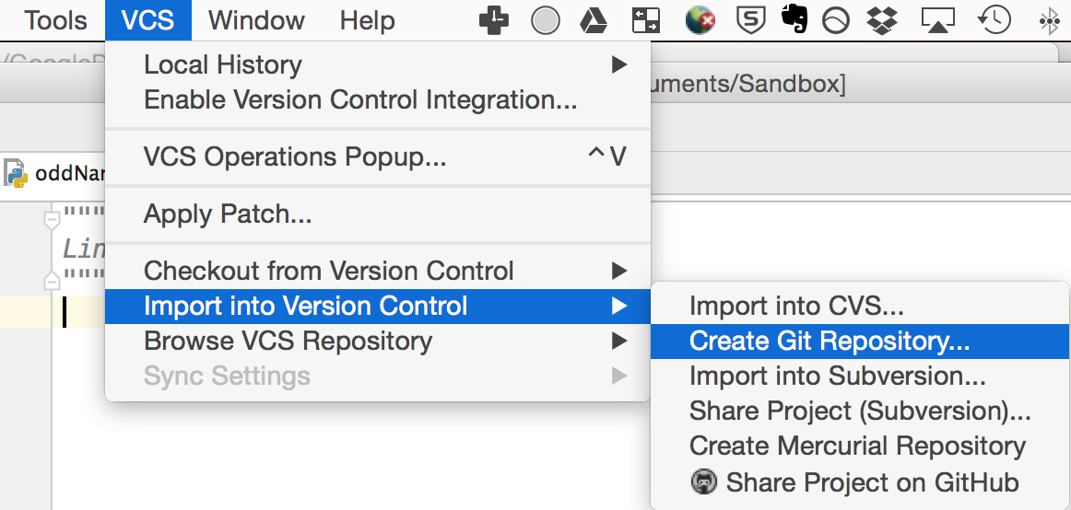  
   Accept the default directory it offers in the next window, which should (must) be the current project directory.  
   What happened? Not much it seems, but we're ready to "commit" our files to Git version control.
4. Choose **VCS > Commit Changes** (take note of the shortcut as you'll be using it often!)  
   It should tell you no changes were detected...  
   Click on the Version Control tool window in the footer (or choose **View > Tool Windows > Version Control**) and click the **Log** tab. It's empty...   
   This is what happens with an empty project and no files marked for staging.
5. Switch to the **Local Changes** tab and you'll see some PyCharm files that we don't care about and our one code file, oddNames.py. Right-click on this file and choose to add it to Git.  
   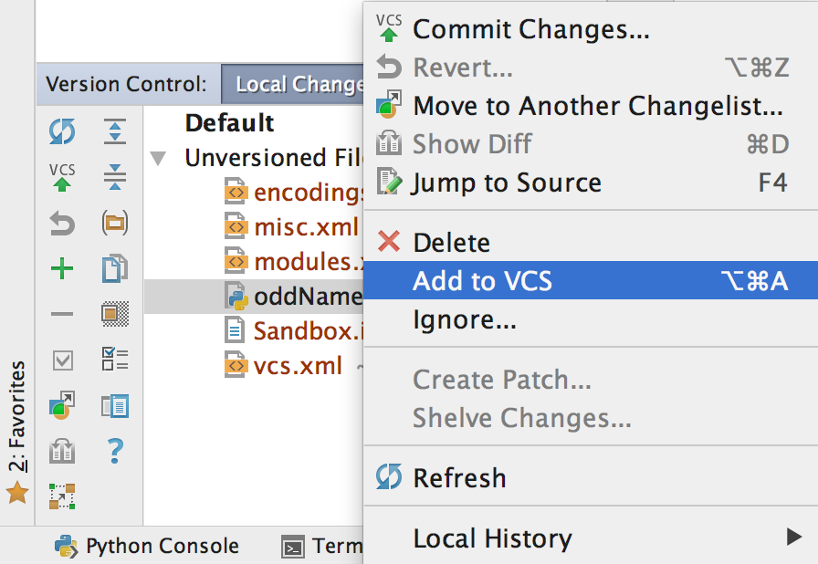  
   (We could have done this in other ways, most commonly by right-clicking on it in the normal Project window.)  
   You should now see it listed under **Default** instead of **Unversioned Files**, and it changes **colour**!
6. Click back on the **Log** tab and... it still shows nothing!   
   That's because we've only added this file to the "staging" state, so it will be included when we commit.   
   This is important. Git only tracks the files we ask it to.   
   If you ever get a prompt to "Add File to Git" for PyCharm project metadata files (anything in the .idea folder, like misc.xml), then say **no**.
7. Now for our first commit!  
   Press the shortcut key for committing changes (Ctrl+K or Cmd+K usually) and enter a **meaningful commit message** that briefly describes what your change was.   
   **Use the imperative mood** for your messages. (This is the same for Python docstrings, by the way.)  
   So don't write like "*Added error checking*" (that's the indicative mood),  
   but rather "*Add error checking*".  
   One way to think about this is that your message goes after "If applied, this commit will ".  
   For this nearly-empty change you might just use "Initialise repository" or "Add starter file".  
   Then click **Commit**.You should now see your first commit appear in the Log tab of the Version Control tool window. Yay!
8. Now type the code you wrote on paper earlier into your Python file. Test it.
9. Do another commit with another useful commit message (perhaps something like "Add name printing program"). See that it also appears in your log.  
   We've now saved the state of our project (just one file) at multiple stages by committing to a local Git repository. We could do this as many times as we want, and we could open previous versions of our   
   files through the Version Control tool window in PyCharm (explore this briefly if you want).
10. Time for GitHub! Choose **VCS > Import into Version Control > Share Project on GitHub**

Enter your GitHub username and password and press Enter  
Do not enter a master password, just **Cancel** this. You never need to use this master password facility.  
Enter a brief description of the repo and **Share** it.  
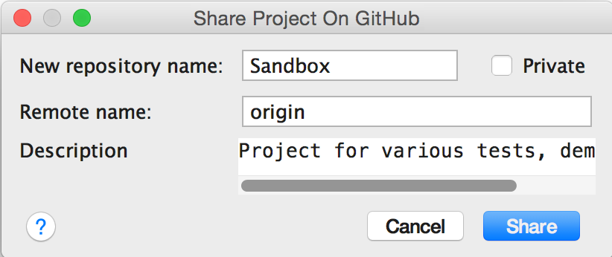

1. If that worked then PyCharm will show you a message in the status bar (very bottom of the window). You can double-click on this to open the event log, then click the Sandbox link to view it in your browser on GitHub. (It will be at the URL like: <https://github.com/yourusername/Sandbox>)  
   You should see that there are 2 commits, and you can click to view these to view them online (including seeing file changes).  
   So now GitHub stores our same Git project from our local computer, including its history.
2. The GitHub website has a suggestion:  
     
   So let's do it. Click the big green button and enter some more brief details (you can always change them later), then click the big green "Commit new file" button (which will accept the defaults).  
   Your repo looks much better online now. READMEs are an important part of software development!
3. But... we did that online in our GitHub repo. There's a new file there, but not locally on our computer.   
   So, let's "**pull**" those changes. In PyCharm, choose **VCS > Git > Pull**, then click Pull (accept defaults).  
   You should now see the README file in your PyCharm project, and if you look, you'll see a 3rd commit (Create README.md) in your commit log.
4. OK, now let's go crazy! Close the project in PyCharm, then delete the whole project from your computer. That's right, delete it all! This is what you would do if you'd finished working on a lab computer and you had committed and pushed all of your changes to GitHub (that is, make sure GitHub has an up-to-date copy of your project).
5. Now, imagine we've moved to another computer on a different day... How do we get keep working on our project? We clone it. Choose **VCS > Checkout from Version Control > GitHub** from the menu or you can get this option from the welcome screen:   
   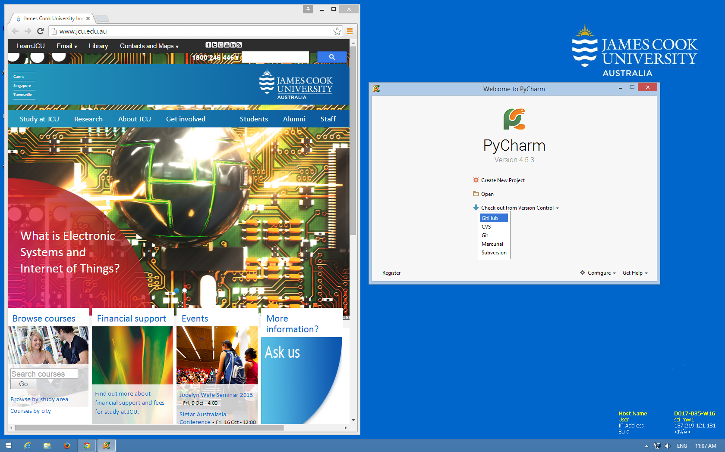  
   Enter the GitHub URL of your Sandbox project, and choose a suitable place on your local computer, then click **Clone**. You now have the whole project, including any previous version history, locally.
6. Add another file, listFiles.py and enter this code:

**import** os  
  
print(**"The files and folders in {} are:"**.format(os.getcwd()))  
items = os.listdir(**'.'**)  
**for** item **in** items:  
 print(item)

1. Run it to make sure it works. It should show you a list of all the files and folders in the current (project) folder, and you should see one called ".git". This is where Git stores all of the history and state information. Don't delete this! If you ever want to move a project file that's using Git, you can either use GitHub (and then clone it to the new place) or you can just copy it – but make sure you get the .git folder.
2. Now **Add** this new file to VCS so Git tracks it, then **Commit and Push** (you should see the option to do both at once), then and check the new file is up on GitHub.

So... we covered a fair bit in that walkthrough. Hopefully you can see the process for working on your projects (including practicals and assignments):

* **Import** any new projects into Git at the beginning
* **Add** new files when you make them
* **Commit** every time you make significant changes
* **Push** to GitHub so you have an up-to-date online copy

Then when you want to keep working on the project again on a different computer

* **Clone** the repository, then add, commit, push, etc.

(If you're working on your own computer you won't need to clone – just keep using the same local repo.)

It is possible to edit and upload files directly via the GitHub website but **we do not recommend this!**

Let's keep going with practical work. Are your pracs on GitHub yet?

Create/open a project in PyCharm and copy your prac files (in their folders), then share it on GitHub.   
From now on, when you finish a task, do a commit with a meaningful message and push it to GitHub. Nice!

You do not need to commit or push for every little change, just for decent-sized changes and especially for milestones or before you start making major changes.

Ideally, each repo should be a PyCharm project. Don’t have one project/repo with other projects/repos inside.

# Intermediate Exercises

## Debugging:

Open your **Capitalist Conrad** program from last week’s practical.

Let’s step through the program using the interactive debugger now…

1. Add a breakpoint on the while line by clicking in the left margin:   
   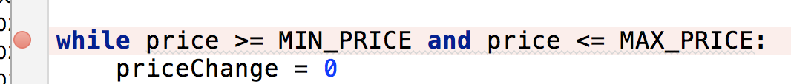
2. Click the “debug” button or choose Run > Debug from the menu or press Shift+F9  
   The program will run until it hits the breakpoint - then stop and show you the current state of the program and its variables (both in the bottom window and in your code)
3. Try all of the different methods for stepping through the program using the toolbar:   
   Screen Shot 2015-08-25 at 9.17.37 am.png

## Functions:

Remember that function names should say what they do (use verb phrases).

Note also that functions should **do one thing** - so they might calculate a value but NOT print it. If they calculated it AND printed it, that would be two things and you could no longer use that function if you wanted to use the value without printing it, e.g. in an expression.

E.g. a function that calculates the area of a rectangle should have the height and width values passed in as parameters, rather than asking the user for them in the function. That way it can be used no matter where the values come from.

From now on, when writing programs with functions, create a main() function for the main part of the program. Put the main function at the top and call it at the bottom. So the basic form is:

**def** main():  
 statements  
 do_stuff()   
   
**def** do_stuff():  
 stuff  
   
main()

Open your program for **Mr Black’s ASCII Lesson** from last week’s practical.

1. Create a function called **get_number(**lower, upper**)** to get a number, making sure that user input is numeric and within the given range.  
   You can use exceptions to check the string is a valid number.  
   Repeatedly re-prompt for a number until a valid one is entered, then return it.  
   e.g. Enter a number (10-50):  
    >>>abc  
    Please enter a valid number!  
    Enter a number (10-50):  
    >>>75  
    Please enter a valid number!
2. When this function works, use it in your program in place of the code you used to get the number.   
   Test it with some invalid and valid inputs.

**That Name Thing with Functions**

At the start you wrote some code for a program that asks the user for their name and prints every second letter in the name. Copy this into your Prac03 folder and commit. Now let's modify this.

1. Move the code inside a main() function and call main at the bottom.
2. **Refactor** the get name part into a separate function... We can do this by using PyCharm's refactoring tool. Select the lines that get and check the name (it should probably be 4 lines) then right-click (or use the main menu) and choose **Refactor > Extract > Method...**  
   Change the name to get_name and press OK.  
   PyCharm should make the function and replace the old code with a call to it like name = get_name()
3. Now refactor the loop that prints the name into a function with parameters for the name and the frequency of letters (1 would be every letter, 3 is every third letter).  
   PyCharm will see that name needs to be an input parameter, but not the number. You'll have to add this yourself. First test it with a literal value for this, then get the value from the user and pass that.

If you have not done so already, please upgrade your account to a free student account at: <https://education.github.com/discount_requests/new> - this allows you to have private repositories for free and you need to use private repositories for your assignments.

# Do-from-scratch Exercises

If you need help with any of these, first ask a classmate - to get used to helping each other - then talk to your tutor.

1. Refactor previous programs to use functions (with suitable verb-phrase names). Copy both of these from prac 1 into prac 3, commit, then update them. We do the commit first so we can see clearly what has changed. We copy them because we want each week's prac folder to contain that week's prac work.
   1. temperatures.py – use 2 functions for converting Celsius to Fahrenheit and vice versa
   2. brokenScores.py (or fixed if you renamed it) – use a function that takes in the score as a parameter, and returns the result to print. The function should not print it; the program should store and print the return value.

If you’re not adding these to previous practical work, then also write some small test programs to show how they work.

# Practice & Extension Work

1. Copy your **word generator** program from last week into a Prac03 folder. Commit.  
   Add error-checking so that you repeatedly validate the user’s input until it is a valid sequence of just c’s and v’s. Create and use a function **is_valid_format()** to return True or False for if the word format is valid or not.  
   **Tip:** use a for loop to iterate through each character in the format sequence and return false if you see one that is not valid.
2. **GPS (Gopher Population Simulator)**  
   A secret population of 1000 gophers lives near the library. Every year, a random number of gophers is born, between 10% of the current population, and 20%. (e.g. 15% of the gophers might give birth, increasing the population by 150). Also each year, a random number of gophers die, between 5% and 25% (e.g. 8% of the gophers might die, reducing the population by 80).

***Write a program that simulates a population of gophers over a ten-year period and displays each year’s population size.***

The output should look something like this (it’s random, so yours won’t be the same):

**Welcome to the Gopher Population Simulator!**

**Starting population: 1000**

**Year 1**

**\*\*\*\*\***

**145 gophers were born. 228 died.**

**Population: 917**

**Year 2**

**\*\*\*\*\***

**124 gophers were born. 152 died.**

**Population: 889**

**Year 3**

**\*\*\*\*\***

**138 gophers were born. 180 died.**

**Population: 847**

**...**

## Learn Git and GitHub

* This guide shows you lots of useful things just using GitHub online:

[Let's get started!](https://guides.github.com/activities/hello-world/) - <https://guides.github.com/activities/hello-world/>

### Git Command Line

Even if you just use the built-in tools in your IDE, you will be able to understand more of what’s happening in Git Version Control if you know the command line tools. Over time you should get experience using both.

So let’s learn more about how Git works and pick up some command line skills by doing the excellent interactive online Git tutorial:

<https://try.github.io>

* [Login to lynda.com](https://cas.secure.jcu.edu.au/cas/login?service=https://www.lynda.com/portal/jcu) and do one or more of the online courses on GitHub: <https://cas.secure.jcu.edu.au/cas/login?service=https://www.lynda.com/portal/jcu>